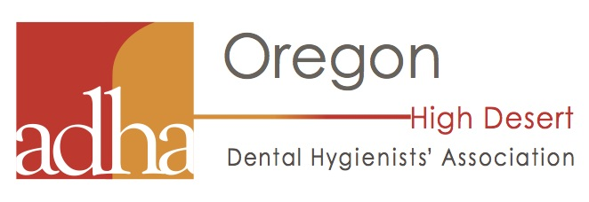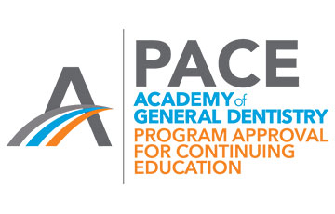

The High Desert Dental Hygienists’ Component invites you to attend
CE Course (2 CEUs): Current Infection Prevention Protocols and Recommendations: Are you in Compliance?
Speaker: Monica Monsantofils, RDH, PG Dip
Date: Thursday, October 11, 2018
Location: COCC Heath Careers Building Room #190 2600 NW College Way, Bend, OR 97703
Time: Sign In & Appetizers from 5:30 – 6:00 pm. Course will start promptly at 6:00 until 8:00 pm
Fees & Registration Information: Online at www.odha.org under the events tab or https://www.odha.org/index.php?option=com_jevents&task=icalrepeat.detail&evid=13
ADHA Members: Free
Non-members RDH, Assistants and Dentists: $50
Course Description:
Infection Prevention is essential for the health and safety of patients and dental health professionals. In order to prevent the transmission of microorganisms and disease requires breaking the chain of infection. This entails performing a series of repeatable and sequential steps for effective infection prevention. The CDC recommendations on infection control for the dental setting include Standard Precautions that should be followed on a daily basis, and includes procedures to be performed at the beginning of the day, before and after treating each patient and at the end of the day. The objective of this course is to provide the dental healthcare professional with an overview of current infection prevention protocols that are required to break the chain of infection and prevent disease transmission.

Course Objectives:

Upon completion of this course, the participants will be able to:
1. Review the elements of Standard Precautions recommended for effective infection prevention
2. Describe engineering and work controls that help prevent the transmission of bloodborne pathogens and other microorganisms
3. Implement effective infection prevention using a sequential and systematic approach that follows the CDC recommendations
About the speaker:
Monica Monsantofils is the West Clinical Educator for DENTSPLY Professional. Monica received a dental hygiene degree from Portland Community College, Bachelor of Science in Dental Hygiene from Eastern Washington University and PG Diploma of Dental Sciences from King’s College London, UK. Monica brings over 30 years of clinical experience in periodontal and general practices and 13 years of academic experience to the Division. Monica’s focus is to provide dental professionals with current concepts and evidence based research to assist them in implementing effective and efficient evidence based treatment protocols in their clinical practice.

